Logical Operators

1) Check whether the file exists and is executable using logical operators.

Hint:man test

Logical.sh

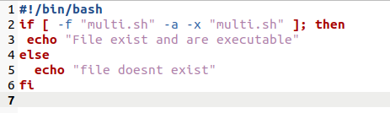

Terminal

